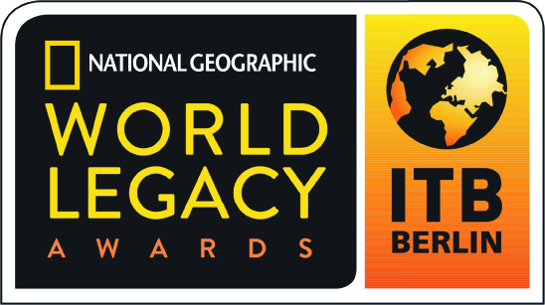

2017 World Legacy Awards

Award Category: Conserving the Natural World - Recognizing outstanding support
for the preservation of nature, restoring natural habitat, protecting rare and endangered species, whether on land or in the oceans.

Applicants in this category will showcase how they are involved in the protection of natural heritage, providing tangible examples of their projects and initiatives, along with outcomes. This may include the protection of wildlife such as terrestrial and/or marine species, expanding and restoring natural habitat, preserving fragile ecosystems, and supporting biodiversity conservation awareness and education among local stakeholders and travelers.

How to Apply: Complete the following application in typewritten English, answering all questions (use N/A if a specific question is not applicable to you). Please do not answer questions by referring to websites, adding links, or using photos in your answers.

Please do not submit any additional materials, such as brochures, CDs or DVDs, press releases, etc., as only the application will be reviewed by the judges.

If you are a previous World Legacy Awards winner or finalist, you may re-apply for an award, but your application should include new initiatives in sustainable tourism that demonstrate how you continue to expand your efforts, building further on your previous recognition.

An organization or company program or project that has been successfully operating for at least twelve months may apply.

Application Deadline: All entries must be received by August 20, 2016. Submit the completed application form to applications@worldlegacyawards.com. Finalists will be announced in December 2016 and Winners will be announced at ITB Berlin in March 2017.

Applicant Information

Name of Company/Organization:

Name/Title of Person Completing Award Application:

Email contact:
Telephone contact:

Complete Address of Company/Organization:

Website of Company/Organization:

Telephone/email of Company/Organization:

Year company/organization started:

If applying for a specific project/initiative, what is the name of your project/initiative and what year did it start?

Please briefly describe your company/organization (Max 100 words):

What is your company/organization’s mission or vision?

Conserving the Natural World

- How does your company/organization contribute to efforts to enhance, protect and support the conservation of the natural world, including protection of terrestrial or marine species, expanding and restoring natural habitat, preserving fragile ecosystems, and supporting biodiversity conservation? Please provide examples of initiatives or projects that you support and how long these efforts have been underway. (Max 200 words)

- How do you monitor and measure the success of your efforts? (Max 200 words)

- How do you educate your guests/clients on your conservation efforts (for example, providing guest information on conservation projects, providing opportunities to support conservation initiatives, promoting leave no trace principles and practices, etc.)? (Max 200 words)

- How do you engage with the wider tourism community in your destination to promote and support conservation of nature (for example, working with local tour operators, suppliers, government authorities, etc.)? (Max 200 words)

- In 200 words or less, please describe what you believe is your most successful and important contribution to protecting natural heritage?

Other Sustainable Tourism Practices

- Do you have environmentally-friendly operating procedures in place (for example: reduce, reuse, recycle; water and energy conservation; efforts to lessen carbon emissions)? Yes/No
If yes, please provide two examples of environmentally-friendly practices that your company/organization supports. (Max 200 words)

- Do you contribute to community projects where you operate (for example: support or collaborate with local organizations involved with education, health care, micro-enterprise development, etc.)? Yes/No
If yes, please provide two examples of community benefit initiatives or projects that your company/organization supports. (Max 200 words)

- Do you contribute to efforts that support sense of place and cultural authenticity, including helping to support artistic traditions in your area, contributing to efforts to promote local culture or helping to safeguard historic sites, using vernacular architecture and traditional design, etc.? Yes/No
If yes, please provide two examples of cultural heritage initiatives or projects that your company/organization supports. (Max 200 words)

Additional Information

In 200 words or less, please describe your company’s overall commitment to sustainable tourism, indicating some of the challenges you have overcome.

References: Please provide the names and contact information for two references who are note employed by your business, but who are knowledgeable about your efforts in regards to Conserving the Natural World, and whom we may contact as references.

Reference 1:
Name:
Company/Organization
Address:
Email:
Telephone:

Reference 2:
Name:
Company/Organization
Address:
Email:
Telephone:

