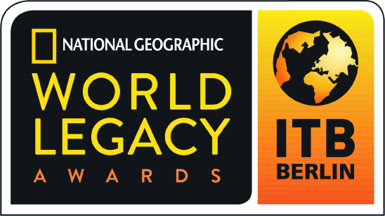

2017 World Legacy Awards

Award Category: Destination Leadership - Recognizing destination stewardship, including cities, provinces, states, countries and regions that are demonstrating environmental best practices, protection for cultural and natural heritage, benefits to local people, and educating travelers on the principles of sustainable tourism.

Applicants in this category may apply on behalf of a destination, and will showcase how they are engaged in a multi-stakeholder process that involves different organizations, businesses, governmental entities, and communities working together to promote and develop sustainable tourism practices at the destination level, delivering meaningful results, and educating travelers about their efforts.

How to Apply: Complete the following application in typewritten English, answering all questions (use N/A if a specific question is not applicable to you). Please do not answer questions by referring to websites, adding links, or using photos in your answers.

Please do not submit any additional materials, such as brochures, CDs or DVDs, press releases, etc., as only the application will be reviewed by the judges.

If you are a previous World Legacy Awards winner or finalist, you may re-apply for an award, but your application should include new initiatives in sustainable tourism that demonstrate how you continue to expand your efforts, building further on your previous recognition.

An organization or company program or project that has been successfully operating for at least twelve months may apply.

Application Deadline: All entries must be received by August 20, 2016. Submit the completed application form to applications@worldlegacyawards.com. Finalists will be announced in December 2016 and Winners will be announced at ITB Berlin in March 2017.

Applicant Information

Name of Company/Organization:

Name/Title of Person Completing Award Application:
Email contact:

Telephone contact:

Complete Address of Company/Organization:

Website of Company/Organization:

Telephone/email of Company/Organization:

Year company/organization started:

If applying for a specific project/initiative, what is the name of your project/initiative and what year did it start?

Please briefly describe your company/organization (Max 100 words):

What is your company/organization’s mission or vision?

Destination Leadership

- How does your destination demonstrate leadership in enhancing, protecting and supporting sustainable tourism practices? Please provide at least two examples and indicate how long these efforts have been underway. (Max 200 words)

- What environmentally-friendly initiatives has your destination implemented (for example: reduce, reuse, recycle campaigns, renewable energy programs, efforts to lessen carbon emissions linked to climate change, etc.)? Please provide two examples and indicate how long these efforts have been underway. (Max 200 words)

- How does your destination contribute to efforts to protect the natural environment (for example: biodiversity conservation projects, wildlife protection, restoration of natural habitat, expanding green space, etc.)? Please provide two examples of nature conservation initiatives or projects that you support and indicate how long these efforts have been underway. (Max 200 words)

- How does your destination contribute to efforts to support sense of place and cultural authenticity (for example: helping to support artistic traditions, contributing to efforts to promote local culture or helping to safeguard historic sites, using vernacular architecture and traditional design, etc.)? Please provide two examples of cultural heritage initiatives or projects that you support and indicate how long these efforts have been underway. (Max 200 words)

- How does your destination provide social and economic benefits to local people through tourism development (for example, capacity building and training, support for community projects, micro enterprise programs, commitment to promoting fair wages and benefits, adherence to fair trade principles, etc.)? Please provide two examples of community engagement initiatives or projects that you support and indicate how long these efforts have been underway. (Max 200 words)

- How do you monitor and measure the success of your efforts in destination leadership? (Max 200 words)

- How do you educate visitors to better understand and support sustainable tourism practices in your destination (for example, incorporating sustainable tourism information in destination visitor information, using local guides and guide training to ensure high quality interpretation, providing information on the importance of protecting natural and cultural heritage, etc.)? (Max 200 words)

- How do you engage with the wider tourism community on ways to embrace sustainable tourism practices and promote destination leadership (for example, engaging community organizations, offering special incentives for locally-owned businesses, promoting local suppliers, encouraging government cooperation and support for destination-wide sustainable tourism programs, etc.)? (Max 200 words)

- In 200 words or less, please describe what you believe is your most successful and important contribution to destination leadership?

- In 200 words or less, please describe your destination’s overall commitment to sustainable tourism principles and practices, indicating some of the challenges you have overcome.

References: Please provide the names and contact information for two references who are not employed by your business, but who are knowledgeable about your efforts in regards to Destination Leadership, and whom we may contact as references.

Reference 1:
Name:
Company/Organization
Address:
Email:
Telephone:

Reference 2:
Name:
Company/Organization
Address:
Email:
Telephone:

