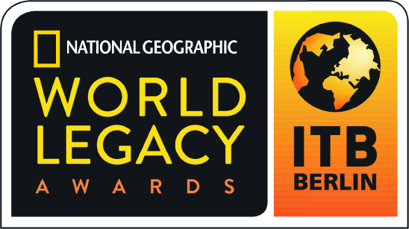

2017 World Legacy Awards

Award Category: Engaging Communities - Recognizing direct and tangible economic and social benefits that improve local livelihoods, including training and capacity building, fair wages and benefits, community development, health care, and education.

Applicants in this category will showcase how they are involved in providing social and economic benefits to local people and host communities. This may include capacity building and training for career advancement in the tourism economy, support for community development projects, and providing opportunities for local communities to become tourism partners and stakeholders, including developing their own businesses.

How to Apply: Complete the following application in typewritten English, answering all questions (use N/A if a specific question is not applicable to you). Please do not answer questions by referring to websites, adding links, or using photos in your answers.

Please do not submit any additional materials, such as brochures, CDs or DVDs, press releases, etc., as only the application will be reviewed by the judges.

If you are a previous World Legacy Awards winner or finalist, you may re-apply for an award, but your application should include new initiatives in sustainable tourism that demonstrate how you continue to expand your efforts, building further on your previous recognition.

An organization or company program or project that has been successfully operating for at least twelve months may apply.

Application Deadline: All entries must be received by August 20, 2016. Submit the completed application form to applications@worldlegacyawards.com. Finalists will be announced in December 2016 and Winners will be announced at ITB Berlin in March 2017.

Applicant Information

Name of Company/Organization:

Name/Title of Person Completing Award Application:

Email contact:

Telephone contact:

Complete Address of Company/Organization:

Website of Company/Organization:

Telephone/email of Company/Organization:

Year company/organization started:

If applying for a specific project/initiative, what is the name of your project/initiative and what year did it start?

Please briefly describe your company/organization (Max 100 words):

What is your company/organization’s mission or vision?

Engaging Communities

- How does your company/organization provide social and economic benefits to local people and your host communities, whether capacity building and training, support for community development, which may include micro enterprise and local business development, fair wages and benefits and adherence to fair trade principles, etc.? Please provide examples of community engagement initiatives or projects that you support and how long these efforts have been underway. (Max 200 words)

- How do you monitor and measure the success of your efforts? (Max 200 words)

- How do you educate your guests/clients on your community benefit initiatives, including engaging with local communities (for example, employing locals in the majority of staff positions, using local guides and guide training to promote positive community interactions, encouraging guests to support locally-owned businesses such as handicrafts, restaurants, etc.)? (Max 200 words)

- How do you engage with the wider tourism community in your destination on ways to engage with local communities and support community benefits (for example, working with local tour operators, suppliers, government authorities, etc.)? (Max 200 words)

- In 200 words or less, please describe what you believe is your most successful and important contribution to engaging communities?

Other Sustainable Tourism Practices

- Do you have environmentally-friendly operating procedures in place (for example: reduce, reuse, recycle; water and energy conservation; efforts to lessen carbon emissions)? Yes/No
If yes, please provide two examples of environmentally-friendly practices that your company/organization supports. (Max 200 words)

- Do you support efforts to protect the natural environment (for example: community conservation projects, wildlife protection, restoration of natural habitat, expanding green space, etc.)? Yes/No
If yes, please provide two examples of conservation initiatives or projects that your company/organization supports. (Max 200 words)

- Do you contribute to efforts to support sense of place and cultural authenticity, including helping to support artistic traditions in your area, contributing to efforts to promote local culture or helping to safeguard historic sites, using vernacular architecture and traditional design, etc.? Yes/No
If yes, please provide two examples of cultural heritage initiatives or projects that your company/organization supports. (Max 200 words)

Additional Information

In 200 words or less, please describe your company’s overall commitment to sustainable tourism, indicating some of the challenges you have overcome.

References: Please provide the names and contact information for two references who are not employed by your business, but who are knowledgeable about your efforts in regards to Engaging Communities, and whom we may contact as references.

Reference 1:
Name:
Company/Organization
Address:
Email:
Telephone:

Reference 2:
Name:
Company/Organization
Address:
Email:
Telephone:

