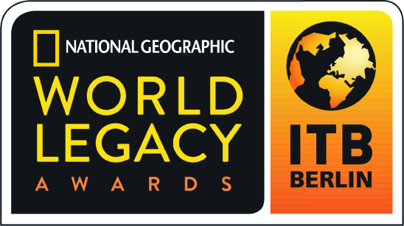

2017 World Legacy Awards

Award Category: Sense of Place - Recognizing excellence in enhancing cultural authenticity, including implementing vernacular architecture and design, support for the protection of historic monuments, archeological sites, indigenous heritage, and artistic traditions.

Applicants in this category will showcase how they are involved in the protection and promotion of cultural heritage, providing examples of their projects and initiatives, along with results. These may encompass implementing vernacular architecture and design, protection of historic sites, support for local cultural and artistic traditions, helping to safeguard indigenous peoples’ heritage, and efforts to share and expand on the importance of protecting cultural heritage, including educating local stakeholders and travelers.

How to Apply: Complete the following application in typewritten English, answering all questions (use N/A if a specific question is not applicable to you). Please do not answer questions by referring to websites, adding links, or using photos in your answers.

Please do not submit any additional materials, such as brochures, CDs or DVDs, press releases, etc., as only the application will be reviewed by the judges.

If you are a previous World Legacy Awards winner or finalist, you may re-apply for an award, but your application should include new initiatives in sustainable tourism that demonstrate how you continue to expand your efforts, building further on your previous recognition.

An organization or company program or project that has been successfully operating for at least twelve months may apply.

Application Deadline: All entries must be received by August 20, 2016. Submit the completed application form to applications@worldlegacyawards.com. Finalists will be announced in December 2016 and Winners will be announced at ITB Berlin in March 2017.

Applicant Information

Name of Company/Organization:

Name/Title of Person Completing Award Application:
Email contact:

Telephone contact:

Complete Address of Company/Organization:

Website of Company/Organization:

Telephone/email of Company/Organization:

Year company/organization started:

If applying for a specific project/initiative, what is the name of your project/initiative and what year did it start?

Please briefly describe your company/organization (Max 100 words):

What is your company/organization’s mission or vision?

Sense of Place

- How does your company/organization contribute to efforts to enhance, protect and support cultural heritage (for example, helping to support artistic traditions in your area, contributing to efforts to promote local culture or helping to safeguard historic sites, using vernacular architecture and traditional design)? Please provide examples of cultural heritage initiatives or projects that you support and how long these efforts have been underway. (Max 200 words)

- How do you monitor and measure the success of your efforts? (Max 200 words)

- How do you educate your guests/clients on the importance of cultural traditions, scared sites, historical areas, etc. (for example, using local guides and guide training to ensure high quality cultural interpretation, providing information on local cultural heritage and appropriate visitor behavior, etc.)? (Max 200 words)

- How do you engage with the wider tourism community in your destination on ways to enhance sense of place and cultural authenticity (for example, working with local tour operators, suppliers, government authorities, etc.)? (Max 200 words)

- In 200 words or less, please describe what you believe is your most successful and important contribution to enhancing sense of place?

Other Sustainable Tourism Practices

- Do you have environmentally-friendly operating procedures in place (for example: reduce, reuse, recycle; water and energy conservation; efforts to lessen carbon emissions)? Yes/No
If yes, please provide two examples of environmentally-friendly practices that your company/organization supports. (Max 200 words)

- Do you contribute to community projects where you operate (for example: support or collaborate with local organizations involved with education, health care, micro-enterprise development, etc.)? Yes/No
If yes, please provide two examples of community benefit initiatives or projects that your company/organization supports. (Max 200 words)

- Do you support efforts to protect the natural environment (for example: community conservation projects, wildlife protection, restoration of natural habitat, expanding green space, etc.)? Yes/No
If yes, please provide two examples of conservation initiatives or projects that your company/organization supports. (Max 200 words)

Additional Information

In 200 words or less, please describe your company’s overall commitment to sustainable tourism, indicating some of the challenges you have overcome.

References: Please provide the names and contact information for two references who are not employed by your business, but who are knowledgeable about your efforts in regards to Sense of Place, and whom we may contact as references.

Reference 1:
Name:
Company/Organization
Address:
Email:
Telephone:

Reference 2:
Name:
Company/Organization
Address:
Email:
Telephone:

